DELFT UNIVERSITY OF TECHNOLOGY  Faculty of Electrical Engineering, Mathematics and Computer Science | 

Homework Unit 4&5 (ET4260) 2026
Semiconductor Sensors & Introduction to Finite Element Modelling

Instructions:
Document your calculations properly with derivations and screenshots when needed.
Please submit your files in word or pdf format. Solutions will be posted one week after submission. Feedback is by self-study.

________________________________________________________________
State here your NAME and STUDENT NUMBER.
________________________________________________________________

Part A: Hall Sensors
Task 1 a):
Considering the material properties given in table 1, which of these intrinsic semiconductors is most suitable to make high-sensitivity Hall sensors? Explain why.

Table 1: Material Properties Si, GaAs, Ge
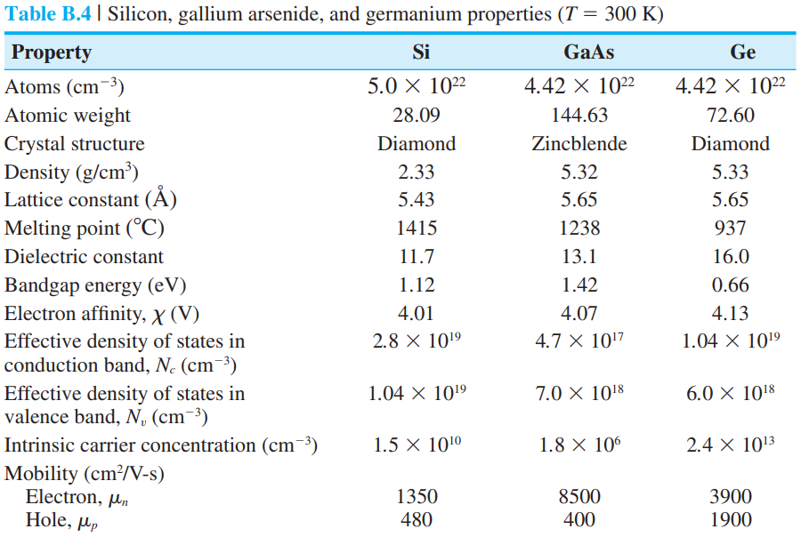

Task 1 b):
Which device parameter links the current-related sensitivity $S_{I}$ and the voltage-related sensitivity $S_{V}$ of a Hall sensor to each other? Why must this parameter be considered as well in designing a Hall sensor?
Task 1 c):
When comparing integrated (including circuitry, such as biasing and read-out) Hall devices, which sensitivity is a reasonable figure of merit?

Task 1 d):
Consider the following GaN-Hall devices from paper [1] given in table 2:
Table 2: GaN Hall Sensor Properties
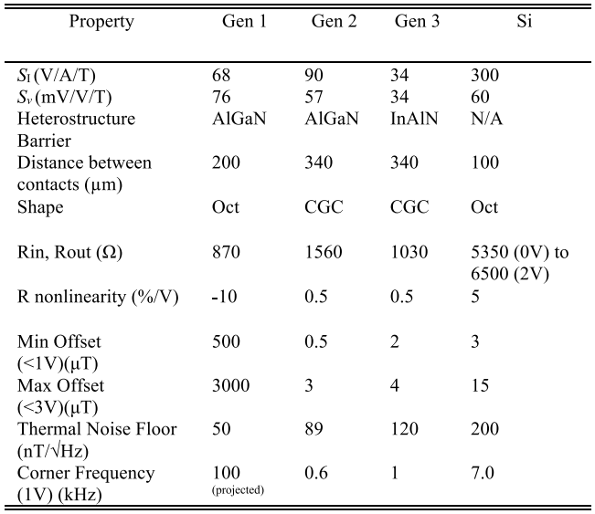

For the Gen 2 devices, the sheet resistance was $R_{□}=430 Ω/□$.
- Calculate ${\left(\frac{L}{W}\right)}_{eff}$ and the geometry factor for the Gen 2 device.
- Given Gen 3 has the same geometry as Gen 2, calculate its’ sheet resistance.
- Calculate the sheet carrier density ($n⋅t$) for Gen 2 and Gen3 in #carriers/cm⁻² as well as the carrier mobility (cm²/Vs). Assume $r=1$ and $e=1.602×{10}^{-19} C$.
- Additional task: Compare the sheet resistance and carrier mobility of the silicon device to the values calculated above, assuming ${\left(\frac{L}{W}\right)}_{eff}=\sqrt{2}$.

Part B: Temperature Sensors
Task 3 a):
Consider the Wheatstone bridge depicted below. The resistances $R_{1}$ and $R_{4}$ are moderately n-doped poly-Si and have a negative TCR of $α_{neg}=-3×{10}^{-4} K^{-1}$ and resistances $R_{2}$ and $R_{3}$ are highly n-doped poly-Si and thus have a positive TCR of $α_{pos}=+5×{10}^{-4} K^{-1}$. All resistances are designed to have a value of $R=1 kΩ$ at $300 K$. Find the bias-related sensitivity of the bridge towards changes in temperature.
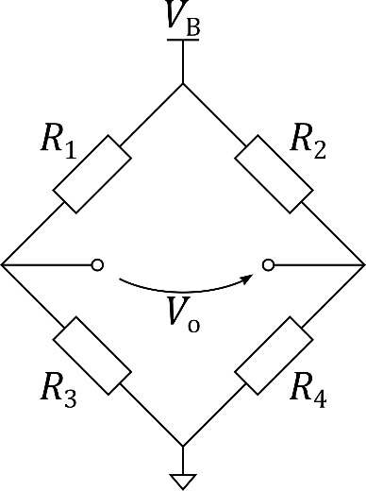
Figure 2: Wheatstone Bridge
Task 3 b):
Compare the statements for output voltage and output rms-noise voltage of a Wheatstone bridge ($R_{1}=R_{3}=R(1+α_{neg}⋅ΔT)$, $R_{2}=R_{4}=R(1+α_{pos}⋅ΔT)$) . How will the SNR generally behave for changing temperature? Assume $α_{neg}={-α}_{pos}$.
Additional task: plot the exact ($α_{neg}≠α_{pos}$) SNR for $T_{0}=300 K≤T≤400 K$, assume $ENBW=1 kHz$, $V_{B}=5 V$ and the $R$ and $α$-values given in part a). $k_{B}=1.381×{10}^{-23} J/K$.
Task 3 c): Additional Task
What measures can be taken so that a measurement with sufficient SNR is possible in the temperature range of interest? What are advantages and disadvantages?

Part C: Photodetectors
Task 2 a):
- Calculate the silicon active device thickness to achieve 90 % and 99 % absorption of light at the wavelengths of 600 nm ($a=4140 cm^{-1}$) and 400 nm ($α=95200 cm^{-1}$).
- Calculate the relative change in quantum efficiency for the thicknesses you calculated for each wave length.
- Calculate the quantum efficiency for each of the wavelengths for 99 % absorption. Assume $R\left(400 nm\right)=0.485$, $R\left(600 nm\right)=0.354$ and $ξ=1$.
Task 2 b):
Consider a piece of n-doped silicon as a photoconductor at room temperature with the following properties:
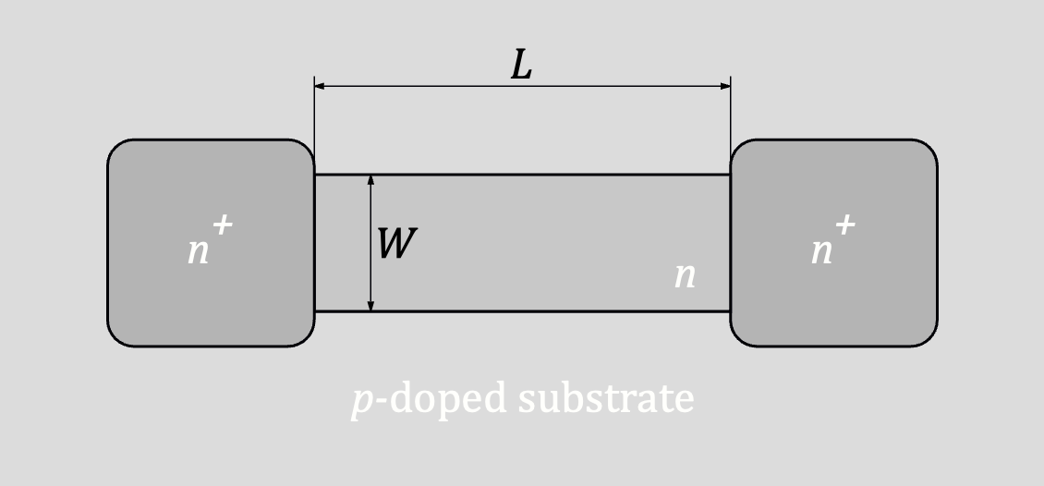
Figure 1: Integrated Photoconductor
Donor concentration of $N_{D}={10}^{17} cm^{-3}$ (assume $n=N_{D}$) and mobilities $μ_{n}=700 cm^{2}/Vs$ and $μ_{p}=240 cm^{2}/Vs$, n-well depth of $t=1 μm$, resistance width of $W=10 μm$ and resistance length of $L=30 μm$.
The photoconductor is driven with a $1.8 V$ bias (only consider the conductor resistance).
- Calculate the current without optical excitation. The intrinsic carrier concentration is $n_{i}=1.5×{10}^{10} cm^{-3}$, the elementary charge is $e=1.602×{10}^{-19} C$ and the Boltzmann constant is $k_{B}=1.381×{10}^{-23} J/K$.
- Calculate the photocurrent for a photon flux of $ϕ=Φ/(L⋅W)={10}^{16} s^{-1}m^{-2}$. Assume $η=0.515$ and $τ=100 ns.$
- Calculate the conductor gain. How much does the gain change in the following situations:
a) the conductor is twice as long ($2L$)
b) the conductor is twice as wide ($2W$)
- How does the photocurrent change for the cases above?

Part D: IS-MOS Capacitance
Task 4 a):
Fill in the gaps for characteristic of a MOS-Capacitance given in the figure below.
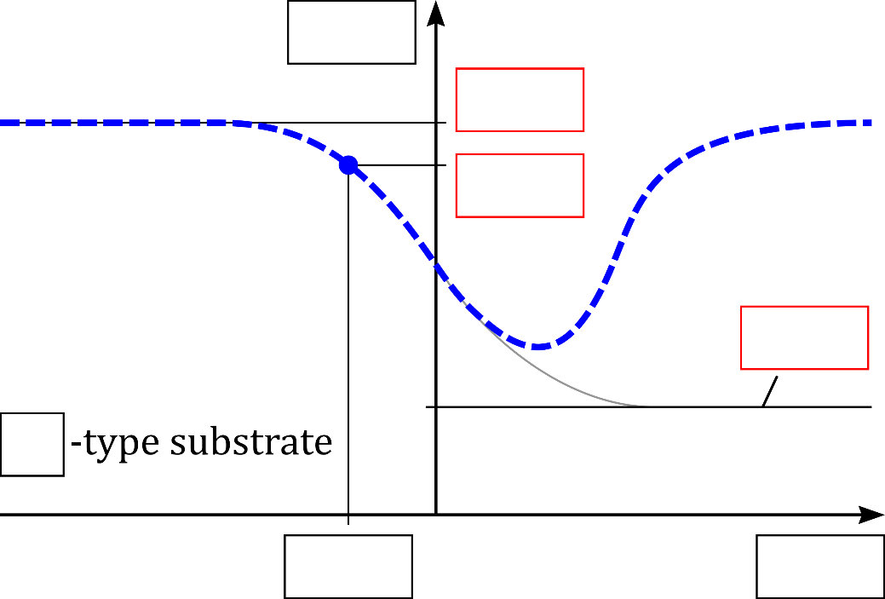
Figure 3: MOS-Cap characteristic
- Calculate the three characteristic parameters (red) of the curve at 300 K. Assume the following parameters:
Gate: silicon dioxide SiO₂, $ϵ_{SiO{}_{2},rel}=3.9$, $t_{ox}=30 nm$
Substrate: silicon Si, $ϵ_{Si,rel}=11.7$, $N_{dopant}=3×{10}^{16} cm^{-3}$
The vacuum permittivity is $ϵ_{0}=8.854×{10}^{-12} F/m$, the intrinsic carrier concentration in Si is $n_{i}=1.5×{10}^{10} cm^{-3}$, the elementary charge is $e=1.602×{10}^{-19} C$ and the Boltzmann constant is $k_{B}=1.381×{10}^{-23} J/K$.
- Calculate how these parameters change if instead of SiO₂ the gate oxide is changed to silicon nitride ($ϵ_{SiN,rel}=7.5$) and the silicon substrates’ doping is decreased to ${0.5×10}^{16} cm^{-3}$. Does this change make for a more sensitive sensor? Assume $ΔV$ between $C_{max}^{'}$ and $C_{min }^{'}$remains the same for both cases.

Task 4 b):
In the image below the blue plot gives an ideal C-V curve for a MOS-Cap with zero charges in the oxide and interface.
Sketch the low-frequency C-V-curve modifications in the plot below for:
- fixed (positive) oxide and interface charges ($Q_{ox}$ and $Q_{ss}$)
- semiconductor with a higher work function
- increased pH in a EOS-Cap pH sensor
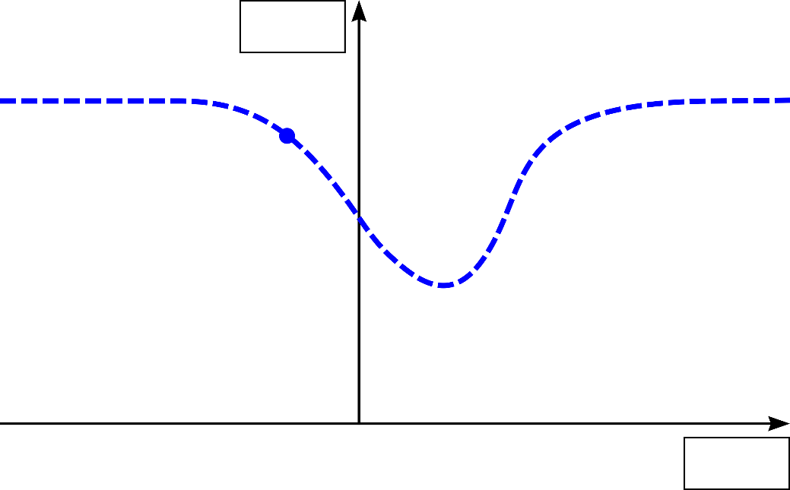
Figure 4: ideal MOS-Cap C-V curve

Task 4 c):
Consider the two EOS-Cap pH-sensors with different oxide material. Calculate the sensor sensitivity ($ΔC/ΔpH$) assuming the devices work in a linear regime ($ΔC/ΔV=const.$) with identical slope for both devices. Dive A has a SiO₂ gate with a sensitivity parameter of ${α_{SiO}}_{2}=0.5$ and device B has a Al₂O₃ gate with $α=0.9$. They work in constant voltage operation.
Task 4 d):
How does the sensor response change if you pick another semiconductor material?

Part E: Introduction to FEM Question from Unit 5
Unit 5 Example Question – this is similar to how we give oral exam questions.
- Describe the 3 key steps to convert a real physical phenomena to a numerical discretization.
- What polynomial order of basis function is ideal for FEM, and explain its tradeoff with other functions with a higher or lower order.
- Propose a qualitative grid spacing to approximate the following curves with linear basis functions (aka hat functions).
